1 ) **Find the culprit**

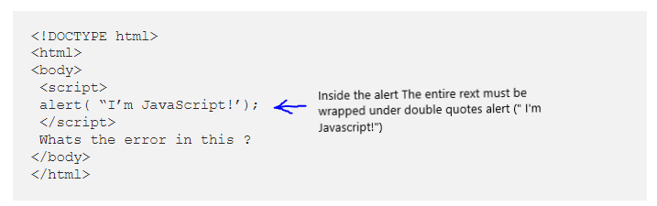

2) **Find the culprit and invoke the alert**

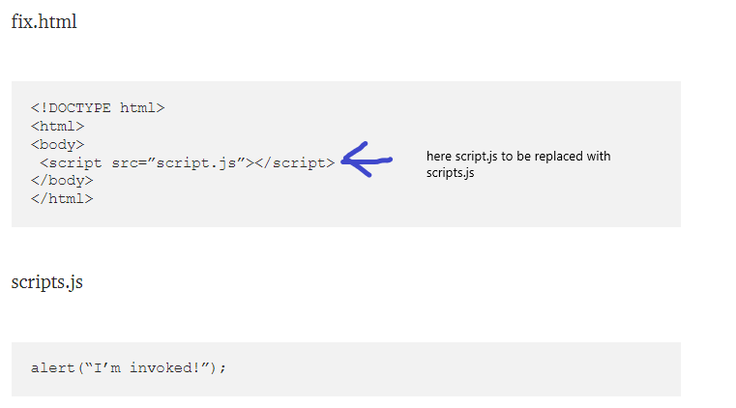

3) **Explain the below how it works**

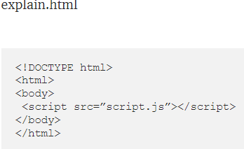

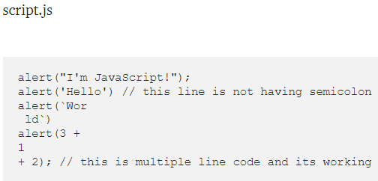

Since JavaScript executes codes line by line,

Second line works without semicolon because js does Automatic semicolon insertion

And the third line works as like it takes enter key after wor, So two lines of code was displayed.

And the code runs until it finds an semicolon for ending the process.

With 4th line, All the inputs are given Number type with + operator, Js does addition in background.

4) **Fix the below to alert**Guvi geek

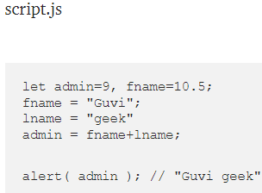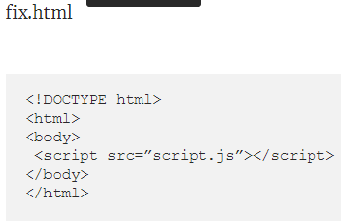

Admin variable must be replaced with admin = fname + “ “ + lname;

5) **Fix the below to alert**hello Guvi geek

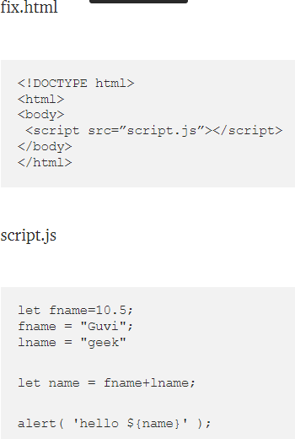

Here, template literals must be inside a backtick

alert (`hello ${fname+” “+lname}`)